**Data Manipulation language (DML)**

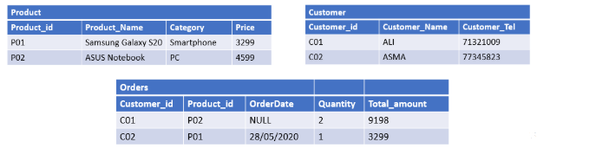

**1/Product Table:**

INSERT INTO Product (Product_id, Product_Name, Category, Price)

VALUES (‘P01’, 'Samsung Galaxy S20', ‘Smartphone’, 3299);

INSERT INTO Product (Product_id, Product_Name, Category, Price)

VALUES (‘P02’, 'ASUS Notebook', ‘PC’, 4599);

**1/Customer Table:**

INSERT INTO Customer (Customer _id, Customer _Name, Customer_Tel)

VALUES (‘C01’, 'Ali', 71321009);

INSERT INTO Customer (Customer _id, Customer _Name, Customer_Tel)

VALUES (‘C02’, 'ASMA', 77345823);

**1/Order Table:**

INSERT INTO Orders (Customer _id, Product_id, OrderDate, Quantity, Total_amount)

VALUES (‘C01’, 'P02', NULL, 2, 9198);

INSERT INTO Orders (Customer _id, Product_id, OrderDate, Quantity, Total_amount)

VALUES (‘C02’, 'P02', TO_DATE ('28-may-2020'), 1, 3299);